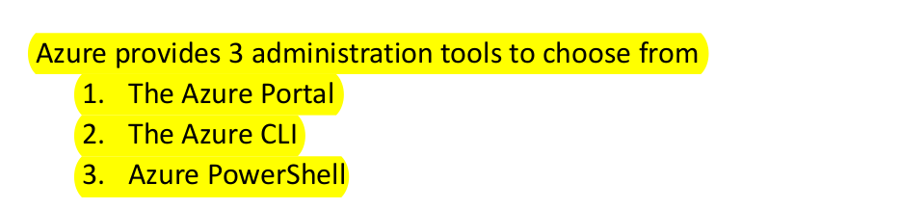

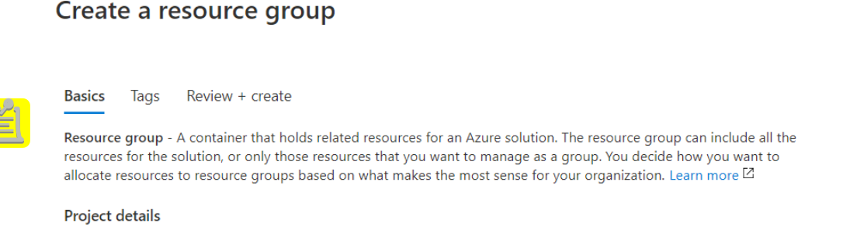

Resource Group : A container that holds related resources for an azure solution. The resource group can include all the resources for the solution, or only the resources that you want to manage as a group.

A Tag consists of a key (name) and a value.

Tag names are case insensitive

Tag values are case sensitive.

You can also click on “Download a template for automation” and download the

template and save it to the library additionally for future use.

The Azure CLI

Azure CLI is a cross-platform command-line program to connect and execute administrative commands on Azure resources.

Azure Powershell